Comparing Performance of Multiple Classifiers for Regression and Classification Machine Learning Problems Using Structured Datasets
Jitendra Shreemaliª, Lokesh Malviya^{b}, Payal Paliwal^{c}, Bhavesh Jindal^{d}, Harshit Chaubisa^{e}
ªTechno India NJR Institute of Technology, Udaipur – 313003, Rajasthan, India
^{b to e} Techno India NJR Institute of Technology, Udaipur – 313003, Rajasthan, India
Abstract
Machine learning aims at improving performance through repeated trials using different classifiers. Given the large number of classification algorithms and difference in their output on account of differing underlying models, it’s important to formulate guidelines on which classification algorithm to use under specific conditions. This study examines the performance of different classifiers on datasets in the public domain and presents a comparison of the results obtained. XG Boost AS is seen to produce superior results when measured in terms of linear regression, standard deviation and mean absolute error found in the test data making it a candidate for consideration for regression as well as classification machine learning problems.

Keywords: Machine learning, Neural network, XG Boost AS, Random forest, CHAID.

Introduction

Machine learning as a subject has generated immense interest among multiple groups of academicians, scientists and industry experts as well as people at large. Beginning with a rather simplistic description that machine learning aims to perform tasks that require human-like cognitive abilities, the definitions evolved to ones that permitted measuring strides in machine learning better. A noteworthy example is viewing machine learning as the study of algorithms that enable computers and computer programs to improve their performance through experience [9]. This is defined more precisely as: A computer program can be said to learning from experience E with respect to some predetermined class of tasks T where the performance is measured on a metric P, if the performance at task(s) T, as measured by P, improves with continued experience E, as provided by input data. An application-oriented definition that speaks of the role of machine learning in prediction through complex models and algorithms in a manner that is repeatable and reliable in terms of associated decisions and results [8]. This often involves uncovering hidden patterns in the historical data to bring out associations hitherto unseen in the datasets collected for the study. Machine Learning approaches can be classified in multiple ways. When based on implementation, one can categorize it into four broad types based on how learning is achieved: (i) Supervised learning wherein the algorithm learns from labeled data; (ii) Unsupervised learning wherein ‘learning’ is the outcome of discovering data patterns or clustering to help establish hitherto unknown relationships and improve decision making; (iii) Reinforcement learning involving penalty associated with solution proposed by the algorithm so as to improve the
Corresponding author. E-mail address:jitendrapshreemali@gmail.com

quality of solution and also ensure improved ‘learning’; and (iv) Semi-supervised learning involving a training set with part of target outputs missing. Yet another classification categorizes learners in classification as eager and lazy learners based on whether the classification model commits to a single hypothesis based on the training data without waiting for the test data (as for eager learners) or waits for the test data and then carries out classification using related data from the stored training data (as for lazy learners) [1]. This difference leads to lazy learners requiring less training time and more time for predicting as compared to eager learners.
The learning process requires sorting or mapping input data into labeled categories of information (or classes) based on a set of specific rules based on the type of inputs. This algorithm performing the learning process is referred to as the classifier and is at the heart of the learning process.

Literature Review

A well posed machine learning problem can be viewed as a study of algorithms that focus on improving performance P at a specific task T with experience i.e. attempts/trials E. It becomes essential to define P so that the measure of performance is consistently understood [9]. Machine learning algorithms aim to achieve improved performance through multiple classifiers. Classification can be defined as the technique that helps categorize data into given classes so as to enable identifying the class a new data point will fall in [4]. It can also be defined as the process of approximating a mapping function from the input features to output variable(s) [1].

The table below gives the results of applying 7 different classifiers to the same problem on two measures, accuracy and F₁ score. The range is 80.11-84.60 percent as regards accuracy and 0.5780-0.6337 as regards the F₁ score. This variation is, by no means, very large.

Table 1: Comparison of results from multiple classifier

Classification Algorithm | Accuracy (Percent) | F₁ Score
Logistic Regression | 84.60 | 0.6337
Naïve Bayes | 80.11 | 0.6005
Stochastic Gradient Descent | 82.20 | 0.5780
K Nearest Neighbours | 83.56 | 0.5924
Decision Trees | 84.23 | 0.6308
Random Forest | 84.33 | 0.6275
Support Vector Machine | 84.09 | 0.6145
Source: https://analyticsindiamag.com/7-types-classification-algorithms/

Accuracy = True Positives + True Negatives
Total Population

F₁ Score = 2 X Precision X Recall
(Precision + Recall)

The list of classifiers includes various linear classifiers like regression (eg. logistic), decision trees, random forest, boosted trees and neural networks [12]. Machine learning algorithms can also be viewed as tools to identify patterns in input features that lead to the output. Supervised machine learning does this using labeled data while unsupervised machine learning does this by identifying hitherto unknown clusters/patterns in the data [6]. Supervised machine learning can be further classified in two categories, namely, regression and classification based on the attribute of the dependent variable, whether, numeric or class based.

Of the different classifiers available to a machine learning practitioner, neural networks have found high acceptance on account of the range of its application as well its progressive learning process.

Fig 1. : Schematic of a single neuron
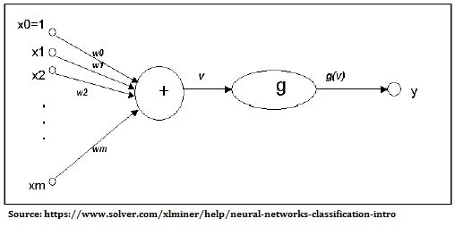

The single neuron above represents aggregation of all inputs after the input itself is multiplied by the respective weight followed by further processing that would typically be non-linear (eg. sigmoid, tanh or relu to name a few) since multiple linear processing adds no value to the learning outcome or improving of results.

An actual neural network includes many such cells where weighted summation is followed by non-linear activation to progressively improve the weights being used and, thereby, the results.

Fig. 2: Schematic of multilayer neural network
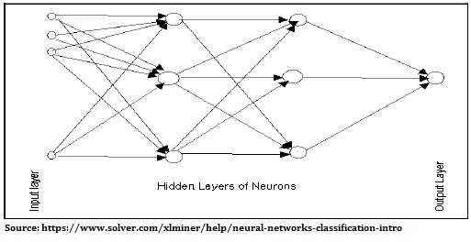

The underlying mathematics is rather simple where one can represent v(X) = Z = Ʃ w_{i}X_{i} + b_{i} with b_{i} representing the bias unit.

The non- linear activation is often represented as g(Z) and average difference between the actual output value y_{i} and machine predicted value g (Z_{i}) squared gives one measure for error (i.ie. loss in the case of regression problems). Successive reduction in the loss value through back propagation allows neural networks to come closer to the ‘actual’ weight values. Actual neural and deep learning often involves learning in steps starting with one kind of features (eg. edges) and slowly evolving the learning in successive layers.

The learning process of a neural network is iterative and after each cycle, the results obtained are compared to the actual results of the training data. Based on whether the problem at hand is a regression or classification problem, loss is calculated and weights updated backwards (through back propagation) to improve the results. This continuous cycle has the potential to produce relatively good results based on certain limitations.

Like the neural network, random forest classifier can also support the needs of regression as well as classification problems. Random Forest algorithm is based on developing decision trees from a subset of the variables that make the original supervised learning problem. Random Forest is a boot-strapping algorithm based on the CART decision trees that develops multiple decision trees using a sample of the data and variables (features) [13]. Finally, an overall tally of outcomes is taken to decide the most likely outcome from the model. The benefits of Random Forest include identifying features that are most important and avoidance of the overfitting problem [14].

Fig. 3: Schematic of Random Forest Algorithm

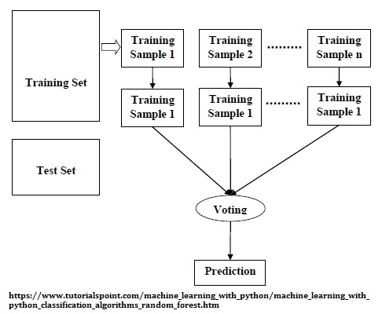

The main limitation of Random Forest Algorithm stems from an apparent contradiction between the need for greater accuracy that comes from increasing the number of trees and speed that is reduced when the number of trees becomes very large [3]. The CHAID Model, like the CART model is among the oldest decision tree models. is an abbreviated form of Chi-Squared Automatic Interaction Detection. CHAID is ideally suited for supervised machine learning problems with continuous or categorical dependent variables where the independent variable is categorical [11]. While the F-test is used for continuous dependent problem as in the case of regression problems, Chi-squared test is utilized where classification is the need as it better addresses categorical variables. The big advantage of the CHAID learning algorithm comes from its in-built Bonferroni Correction where in each successive comparison would lead to a 0.95 chance of correct decision meaning that a 20 fold comparison could lead to a mere 35% chance of the decision being accurate. CHAID addresses this limitation and keeps the chances of rejecting a hypothesis that deserves to be accepted at the level of significance, that is, generally 5%.

Generalized Linear Models represent a family of models that include linear and logistic models besides other models wherein a model that best explains the behavior of training dataset is put together using an expression that demonstrates linear combination of variables). Examples of such models are the Bernoulli’s distribution for binary data, Poisson distribution for counting-based-data and Gaussian distribution for data that takes real values. Broadly speaking, these distributions can be viewed as belonging to a class of exponential distributions where the probability distribution function can be expressed in the following general terms [6]:

P (y; n) = b (y). Exp (n^{T} * T (y) – a (n)) where:

n is a natural parameter that could be a vector or scalar
a (n) is a log partition function (purely a function of eta)
y represents the target (label) data
b (y) is purely a function of y
T (y) represents sufficient statistics (= y, here)

Generalized linear models are used to varying degree of complexity, the simplest being the linear regression where: y (i) = α + β (X_{i}) with α, β as the constant coefficients

Since relatively few real world variables follow the linear model above, the need arises to consider variants that better explain real world variable behavior. Log linear relationship is expressed as: y (i) = α. β ^{x}

Besides the classifiers mentioned above the availability of multiple models in the IBM SPSS Modeler permitted their use for comparison of results. This study aims to investigate the variation in results produced by different machine learning classifiers and analyze the same. With growing number of tools available to practitioners of machine learning, there is a need to categorize them properly so that the need for trial-and-error attempts by practitioners is minimized, if not eliminated.

Methodology

This study used data from the placement data set at Kaggle website: https://www.kaggle.com/benroshan/factors-affecting-campus-placement. The students under consideration relate to the MBA program. The features in dataset include: (i) Gender; (ii) Senior School Percentage; (iii) Senior School Board; (iv) High School Percentage; (v) High School Board; (vi) High School Stream; (vii) Degree Percentage; (viii) Degree (Commerce, Science and Technology or others); (ix) Work experience; (x) Employability Test Performance; (xi) Specialization; (xii) MBA percentage; and (xiii) Status as well as salary, if placed. The last field was selected as the ‘Target’ field so that could be predicted based on the preceding fields. Multiple machine learning models were run and results from these models were compared to check if a pattern can be observed in the results obtained and if one model performed significantly better than other models in predicting the target variable. The problem was presented to models as a regression as well as classification problem to provide added inputs on model performance. As a second check, data on school dropouts at https://www.kaggle.com/vidyapb/indian-school-education-statistics/discussion/176403 was also run through multiple classifiers and results compared. The dataset provides details of school infrastructure (water, electricity, computers and toilets) and also enrolment and dropout data for all years. This was done to validate the findings of the first part and see if the same or different model performed better than others in predicting the target variable.

RESULTS AND DISCUSSIONS

Given below are the findings of employing different classifiers and also varying the train:test split ratio. The initial part of this study aimed at predicting the salary based on multiple machine learning models. Those findings are given below for each of the parameters measured:
Salary being a continuous data type, allows usage of multiple models/classifiers. Comparing predicted salary with actual salary permits use of multiple metrics. Of these three were employed, namely, linear correlation, standard deviation and mean absolute error. The results on these are presented below:
As a part of the study of multiple classifiers, even the training dataset results are presented to highlight the wide variations across classifiers. The training results of analysis are briefly presented below for one of the datasets with results of test data forming the main chunk of subsequent part of this report.

Table 2: Predicted v/s Actual Salary: Training dataset
Train:Test Split = 80:20  Model/Classifier | Linear Correlation | Standard Deviation | Mean Absolute Error
Neural Network: 1-hidden (7 nodes) | 0.562 | 79676.90 | 51559.96
Neural Network: 2-hidden (8-6 nodes) | 0.880 | 46526.95 | 34311.71
Random Forest | 0.926 | 42264.83 | 24686.70
XG Boost AS | 0.981 | 29565.52 | 18600.64
XG Boost | 0.990 | 26132.31 | 17233.43
CHAID | 0.223 | 93885.75 | 57438.30
Gen. Linear | 0.436 | 86654.66 | 55434.49
Tree AS | 0.357 | 89950.86 | 53657.05
Ensemble (Auto-classifier) | 0.911 | 57206.65 | 38352.25

The wide variation in all values shows that for a given data set, the different classifiers are by no means equal. The linear correlation values are seen to vary from 0.223 to 0.990 i.e. a ratio of almost 1:4, the standard deviation varies from 26132.31 to 93885.75 i.e a ratio of over 1:3 while mean absolute error varies from 17233.43 to 57438.30, again a ratio of over 1:3.

Fig. 4: Variation in Linear Correlation (Training)
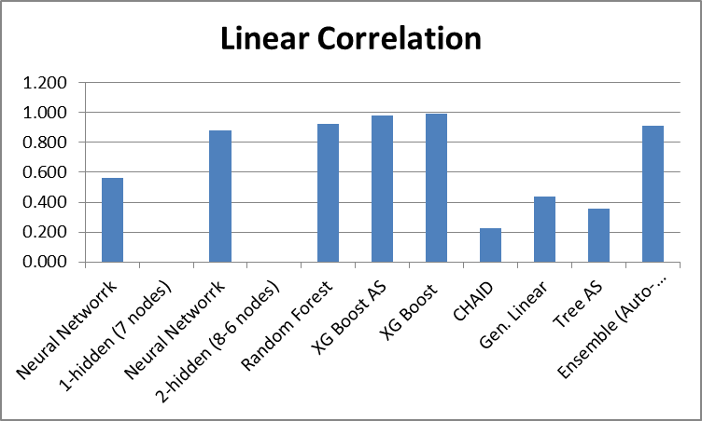

Despite the wide variation, it can be seen that for the training data 5 classifiers provide linear correlation value of over 0.88. Similar behaviour was observed when the salary variable was converted into categorical variables by specifying salary ranges in a manner where population mean were very close to each other. This is shown in the table below:

Table 3: Correct Classification: Training dataset
Model/Classifier  Train:Test Split = 70:30 | Correct Percentage
Neural Network: 1-hidden (7 nodes) | 48.97
Neural Network: 2-hidden (8 & 6 nodes) | 54.48
Random Forest | 67.59
XG Boost AS | 94.90
XG Boost | 64.14
CHAID | 93.10
Gen. Linear | 32.41
Tree AS | 48.97
Ensemble (Auto-classifier) | 93.79

Once again accurate classification ranges from about 32% to close to 95%, a variation of 1:3 and once again one can observe multiple classifiers showing ‘superior’ results but the classifiers that produce good results for a regression problem are not the same as those producing ‘superior’ results when the problem is converted into a classification problem.

Fig. 5: Correct Classification (Training)

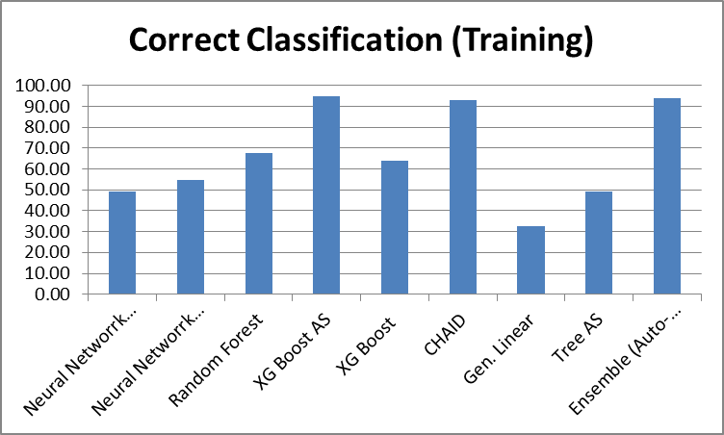

It is observed that despite the variation, multiple classifiers are seen to achieve over 90% correct classification. The results of the training data set are generally seen to outperform the test data results. Also, for machine learning practitioners, it is the results of tests data that are more important and subsequent part of this study focuses on the test data. Given below is the variation in linear correlation values across multiple classifiers with a small change in the train: test ration i.e. 80:20 and 70:30. Use of two ratios would give a better understanding if any one model out-performs other models for different combinations of train:test ratio.

Table 4: Linear Correlation (predicted v/s actual salary): Test
 | Linear Correlation | Linear Correlation
Model/Classifier | Train:Test Split = 80:20 | Train:Test Split = 70:30
Neural Network: 1-hidden (7 nodes) | -0.019 | 0.239
Neural Network: 2-hidden (8-6 nodes) | 0.351 | 0.197
Random Forest | 0.012 | 0.027
XG Boost AS | 0.987 | 0.984
XG Boost | 0.028 | -0.066
CHAID | -0.043 | 0.051
Gen. Linear | 0.003 | 0.222
Tree AS | 0.099 | 0.051
Ensemble (Auto-classifier) | 0.088 | 0.223

A graphical representation of the data above is presented below to emphasize the wide variation in correlation values and better performance by XG Boost AS when compared to other machine learning models. It is noteworthy that the performance is better than the Auto-classifier (ensemble) model.

Fig. 6: Linear Correlation (predicted v/s actual salary): Test

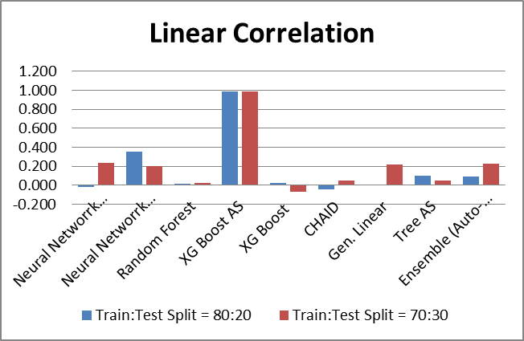
As far as linear correlation is concerned only neural network with 2 hidden layers (8 and 6 nodes) and XG Boost Trees AS provide values that could be regarded as worthy of being considered. Within these XG Boost Trees AS gives values that by far the best results in terms of linear correlation between values predicted and actual values. Further a change in train:test split does have an impact on the linear correlation values in every case making it an important hyper parameter for tuning to improve performance.
The variation in standard deviation vis-à-vis test data shows a similar trend as shown below. The XG Boost AS model shows a much lower standard deviation than others.

Table 5: Standard Deviation (predicted v/s actual salary): Test
 | Std. Deviation | Std. deviation
Model/Classifier | Train:Test Split = 80:20 | Train:Test Split = 70:30
Neural Network: 1-hidden (7 nodes) | 103388.57 | 95284.20
Neural Network: 2-hidden (8-6 nodes) | 96469.63 | 95343.15
Random Forest | 103239.29 | 104219.59
XG Boost AS | 32126.49 | 31524.56
XG Boost | 94593.56 | 112134.68
CHAID | 89437.95 | 98061.54
Gen. Linear | 95286.56 | 96007.03
Tree AS | 86920.18 | 98061.56
Ensemble (Auto-classifier) | 96985.84 | 94866.75
A graphical representation of spread as regards standard deviation is given below:

Fig. 7: Standard Deviation (predicted v/s actual salary): Test

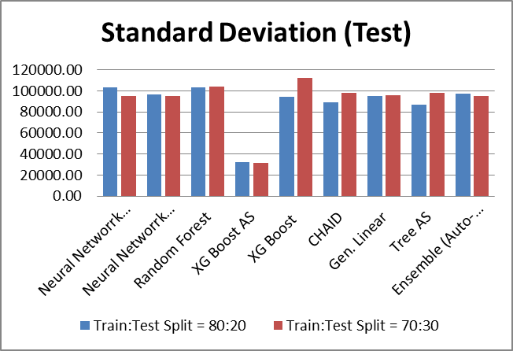
Variation in mean absolute error is shown next. Here too the results obtained show a wide variation (from less than 20000 to greater than 70000) re-emphasizing the need for a classifier that addresses the business need best.

Table 6: Mean Absolute Error (predicted v/s actual salary):Test
 | Mean Abs. Error | Mean Abs. Error
Model/Classifier | Train:Test = 80:20 | Train:Test = 70:30
Neural Network: 1-hidden (7 nodes) | 65328.74 | 62996.67
Neural Network: 2-hidden (8-6 nodes) | 71497.71 | 63075.07
Random Forest | 69433.33 | 66753.00
XG Boost AS | 19493.78 | 20135.85
XG Boost | 55810.73 | 58898.38
CHAID | 60112.66 | 62642.27
Gen. Linear | 60594.11 | 60426.61
Tree AS | 50432.51 | 62642.27
Ensemble  (Auto-classifier) | 65560.11 | 59929.56

The mean absolute error of the next best classifier after XG Boost AS is nearly 2.5 times that of XG Boost AS showing the significant reduction in error value.
Fig. 8: Mean Absolute Error (predicted v/s actual salary): Test
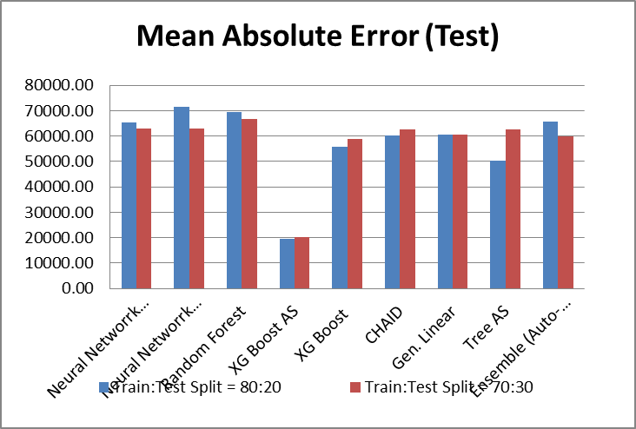
In all cases above, salary being a number, was treated as a continuous variable. Since precise figure could very well be replaced by a range, the salary (continuous) data was converted into nominal data (salary range) and processed as a target field using multiple models. The results of such

Table 7: Results from different classifiers: Salary range
 | Percent Correct Classification | Percent Correct Classification
Model/Classifier | Train:Test = 80:20 | Train:Test = 70:30
Neural Network: 1-hidden (7 nodes) | 60.00 | 49.29
Neural Network: 2-hidden (8-6 nodes) | 56.36 | 54.29
Random Forest | 52.73 | 60.00
XG Boost AS | 69.09 | 94.00
XG Boost | 30.91 | 65.71
CHAID | 56.36 | 91.43
GLMM | 29.09 | 28.57
Random Trees | 18.18 | 12.86
Tree AS | 27.27 | 55.71
Ensemble (Auto-classifier) | 58.18 | 92.86
A schematic representation of this variation is given below. The variation for the 80:20 split is in the range of about 18% to 69% while the variation for the 70:30 split is still larger and falls in the range of about 13% to 94%.

Fig. 9: Results from different classifiers: Salary range
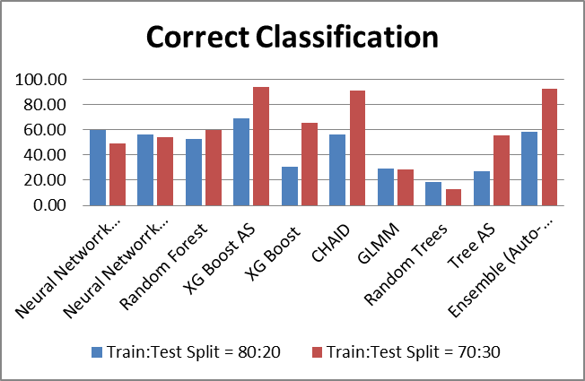

The diagrammatic representation shows that a different train:test split leads to a different classifier producing better results. While the XG Boost AS model performs best in both cases, other models do not show a very consistent pattern in results produced for different split in train:test ratio.
Similar results were obtained when multiple classifiers were applied to the dataset from Kaggle on school dropouts (https://www.kaggle.com/vidyapb/indian-school-education-statistics/discussion/176403). Data for secondary dropouts for the years 2013-14 and 2014-15 was considered for different states across the country. Results of running these models on the dataset with dropout percentage among boys and girls as targets are given below.

Table 8: Secondary School Dropouts: Boys
Model/Classifier  (Secondary Boys) | Linear Correlation | Standard Deviation | Mean Abs. Error
Neural Network: 1 Hidden (7 Nodes) | 0.775 | 7.241 | 5.815
Random Forest | 0.502 | 7.009 | 5.721
XG Boost AS | 0.969 | 2.406 | 1.964
XG Boost | 0.418 | 7.502 | 6.344
Ensemble (Auto-classifier) | 0.775 | 6.229 | 4.811

The data above follows the same pattern as earlier findings and is graphically presented below:

Fig. 10: Secondary School Dropouts: Boys
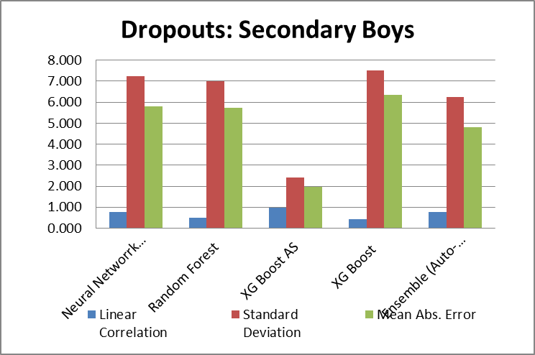

The linear correlation bar being smaller is only because linear correlation cannot exceed a value of 1. Results of applying multiple classifiers on secondary school dropouts among girls are given below.

Table 9: Secondary School Dropouts: Girls
Model/Classifier  (Secondary Girls) | Linear Correlation | Standard Deviation | Mean Absolute Error
Neural Network: 1 Hidden (8 Nodes) | 0.366 | 7.730 | 6.308
Random Forest | 0.621 | 7.233 | 6.108
XG Boost AS | 0.986 | 1.779 | 1.516
XG Boost | 0.715 | 6.337 | 5.283
Ensemble (Auto-classifier) | 0.746 | 5.918 | 4.154

The data above is graphically presented below:

Fig. 11: Secondary School Dropouts: Girls

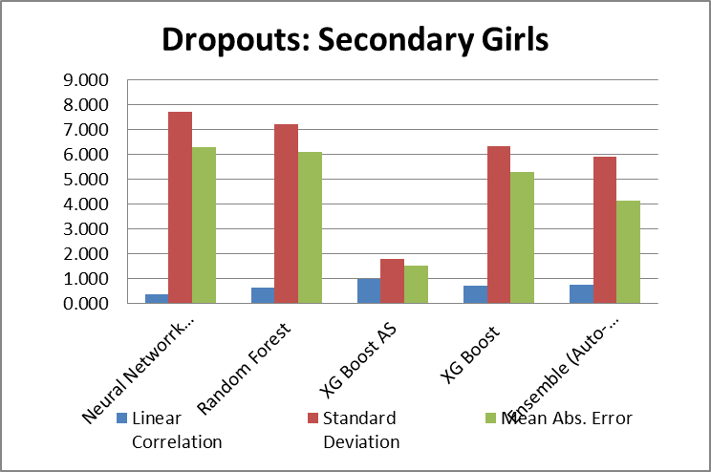

In this case too, the results obtained from applying XG Boost AS classifier are by far the best.

The XG Boost AS algorithm node provided by IBM SPSS Modeler is very easy to use and is implemented in Spark. The use of XG Boost or eXtreme Gradient Boosting algorithm for structured or tabular data is attributed to it’s gradient boosting to fine tune the learning rate, stochastic gradient boosting that allows subsampling at multiple levels and L1 as well as L2 regularization for regularized gradient boosting [2]. It’s strengths include model performance as seen in the study above and execution speed and it’s added features include: (i) parallel tree construction during training through multiple CPU cores; (ii) ability to perform distributed computing so that very large models can be trained using multiple machines; (iii) ability to handle huge datasets that cannot be accommodated into memory through out-of-core computing; and (iv) optimal use of hardware through cache optimization. The strengths of XG Boost algorithm lies in processing tabulated or structured data just as neural networks have proven strengths in processing unstructured data (eg. images) [10].

Fig. 10: The Continuous Evolution of Decision Trees

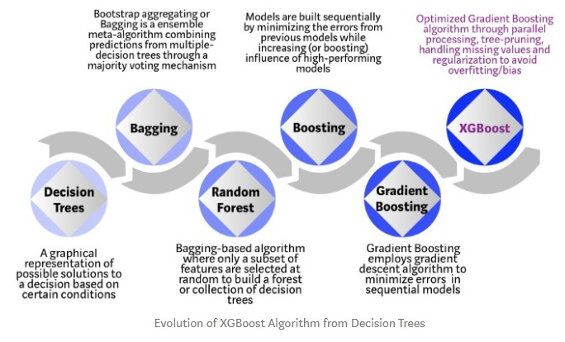
Source: https://towardsdatascience.com/https-medium-com-vishalmorde-xgboost-algorithm-long-she-may-rein-edd9f99be63d
In a short span of about 4 years, XG Boost algorithm, application of XG Boost algorithm has grown enormously on account of its very wide application range (can be used all the way till user defined prediction problems through classification, regression and ranking machine learning problems), it’s portability, range of languages it supports and cloud integration.

CONCLUSIONS

While the presence of a large number of classification algorithms indicates a growing interest in machine learning, practitioners also need to identify the classification algorithm that applies to their data for getting the best results. These classification algorithms present vastly different results on measures like linear correlation, standard deviation, mean absolute error or even a simple measure like accuracy of classification. XG Boost AS classifier emerges as candidate for consideration on account of its superior performance especially when dealing with structured data. It is also seen that classifiers that produce the best results for a regression problem are not necessarily seen to produce the best results when the same problem is viewed as a classification problem.
Thus, a rough picture begins to appear in a rather hazy manner wherein neural networks (with several other hyper parameters also requiring tuning in) could be an option to be considered for good results while for structured datasets XG Boost presents indisputable strengths on multiple measures. Given the very wide scope of machine learning applications, it is quite possible that the coming times may see added focus in machine learning applications and advancements based on unique characteristics of specific domains/areas.

Limitations Of The Study

And

Scope For Further Researh

Both data sets used here were small in size and contained less than 10 features. While XG Boost AS algorithm may be quite well equipped to handle large datasets with a much greater number of features, an actual comparison of its results with those from other classifiers would add to the body of knowledge and help formulate an approach on choice of classifiers for a given machine learning problem. This, then, represents the main limitation of this study and presents an opportunity for further study on the subject. The research here also presents the possibility of domain specific algorithms that take into account its unique characteristics and presents an opportunity for categorization of various domains and checking if the underlying data vector requires separate algorithms or not.
References
- Asiri, S. (2018). Machine Learning Classifiers. Retrieved from: https://towardsdatascience.com/machine-learning-classifiers-a5cc4e1b0623
- Brownlee, J. (2016). A Gentle Intrduction to XGBoost for Applied Machine Learning. Machine Learnng Mastery, Retreved from https://machinelearningmastery.com/gentle-introduction-xgboost-applied-machine-learning/
- Donges, N. (2019). A Complete Guide to The Random Forest Algorithm. Retrieved from: https://builtin.com/data-science/random-forest-algorithm
- Garg, R. (2018). 7 Types of Classification Algorithms. Retrieved from: https://analyticsindiamag.com/7-types-classification-algorithms/
- GeeksforGeeks (2020). Generalized Linear Models. Retrieved from: https://www.geeksforgeeks.org/generalized-linear-models/
- GeeksforGeeks (2020). Regression and Classification: Supervised Machine Learning. Retrieved from: https://www.geeksforgeeks.org/regression-classification-supervised-machine-learning/
- IBM SPSS Modeler on XG Boost AS node. Retrieved from: https://www.ibm.com/support/knowledgecenter/SS3RA7_sub/modeler_mainhelp_client_ddita/clementine/xgboost_as.html
- Pandey, S. (2020) for GeeksforGeeks. An Introduction to Machine Learning. Retrieved (13-02-2020 update) from: https://www.geeksforgeeks.org/introduction-machine-learning/
- Mitchell, T.M, Machine Learning, McGraw Hill, 1997. Retrieved from: http://profsite.um.ac.ir/~monsefi/machine-learning/pdf/Machine-Learning-Tom-Mitchell.pdf.
- Morde, V. (2019). XG Boost Algorithm: Long May She Reign. Retrieved from: https://towardsdatascience.com/https-medium-com-vishalmorde-xgboost-algorithm-long-she-may-rein-edd9f99be63d.
- Ramzai, J. (2020). Simple Guide for Two Types of Decision Trees: CHAID and CART. Retrieved from : https://towardsdatascience.com/clearly-explained-top-2-types-of-decision-trees-chaid-cart-8695e441e73e
- Sidana, M. (2017). Intro to types of classification algorithms in Machine Learning. Retrieved from: https://medium.com/sifium/machine-learning-types-of-classification-9497bd4f2e14
- Srivastava, T. (2014). Introduction to Random Forest – Spimilified. Retrieved from: https://www.analyticsvidhya.com/blog/2014/06/introduction-random-forest-simplified/
- Synced (2017). How Random Forest Algorithm works in Machine Learning. Retrieved from: https://medium.com/@Synced/how-random-forest-algorithm-works-in-machine-learning-3c0fe15b6674

